Our Staff
When we started Hierogamous Enterprises in June, 1989, desktop publishing was already one of our long range goals. HE Helps temporary services one of the enterprises, but it wasn't until late 1999 that we finally finished writing Hierogamous Hymns, our first book and the first edition did not actually get printed until January 2000, providentially the year of the Great Jubilee!
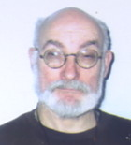
Michael Joseph James Halm was conceived New Years Day, 1947, born over two months premature, did graduate work in physics, studied education, creative writing and then sold his first poem in 1975. He has received an honorary doctor's degree from the CLEO Society and a knighthood from the Militia Immaculata. He is a lifelong member of Presentation Ministries, the lay association which publishes My People newspaper, of the Secular Franciscans, the first tertiary order, founded by St. Frances of Assisi, and of the Universal Living Rosary, a worldwide perpetual prayer group. He was coordinator of three American Mensa SIGs, the Fortean Mysteries SIG, the Mythopoeic SIG and the Holmesian Studies SIG. With Razilee Purdue he co-authored Hierogamous Hymns, the first of our publications. For other of his accomplishments see his resume. For his family history see his genealogy page.
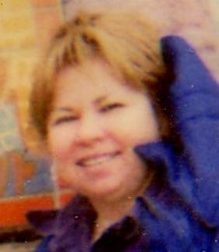

Kathleen Ann McCarthy was the author of Hierogamous Enterprise's second book, The Luminous Mysteries: A Pay for 8 to 10 year Olds Kathy was a member of St. Dominic Roman Catholic Parish in Cincinnati, Ohio. She received a Catechist's Certificate at the highest level from the Archdiocese of Cincinnati. She has taught religion to grade school children in the Archdiocese of Cincinnati for over ten years. She wrote and directed her first play on the joyful mysteries of the rosary with her 15 third-grade students who performed it in front of the other religious education classes in the parish. That play was published in Religion Teacher's Journal. Kathy has also been in the cast of the St. John Passion Play performed in Cincinnati, Ohio. She died in 2009.
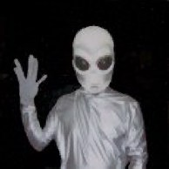
Lemcia Mal is our visitant alien expert xoologist at the IDIC Institute, major contributor to The Xoo Book and so bright that his head glows in the dark.

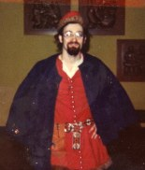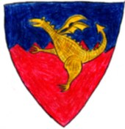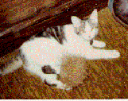
Percival de Toulouse, his coat of arms and companion, Lady Mae C'Mell (with tribble)
Percival was born in Toulouse, France, in 1215 to returning crusader Sir Ferdinand de Bretagne and Vivianne de Toulouse, a revert from Albegensianism. Having supported himself as a book copier, he was eventually licensed as a Master of Arts at the University of Toulouse and, possibly because of trouble with the Inquition, continued his studies at the University of Paris. He travelled extensively, like his father, and so became known as Doctor Peregrinabundus (in Welsh aka Purcyfaill Ap Fergananym) visiting Al-Azhar, Baghdad, Germany, India, Italy, Khanbaniq, Khmer, Lamary, Mabaron, Melibar, Mecca, Mydden Seren, New Canterbury, Nothumberland, Palermo, Pathan, Polombe, Scotland, Susa, Toledo.
He discovered the world of SCA in A. S. X. he founded the North Woods baronial Alchemists' Guild under Dagan du Darregonne, assisted dance mistress Megan of the Greenwood, and roomed with Brusten de Bearsul. He contributed to Destrier and The Pale. While researching Descendants of St. Clotilda he discovered his Scandinavian, Hun, Irish, Jewish, Russian, Saxon, Visigoth, and Welsh ancestry. In A. S. XIII he founded the shire of
Glenngliondrach. He was last known to be living in the barony of F enix.
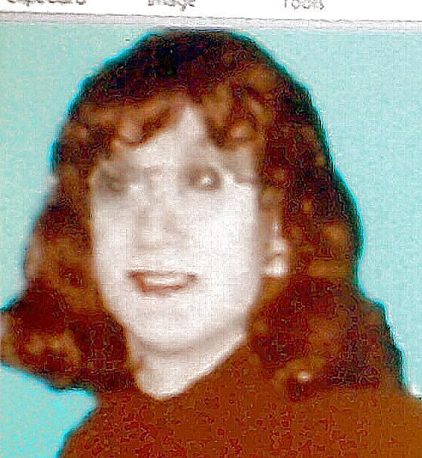

Razilee Mary Purdue also came into the world rather unexpectedly July 11, 1967, during a troubled time when her parents were talking divorce. They stayed together, but in 1976 she had a brief sexual relationship with a 21-year-old female "friend". She never did graduate from high school. She, like Michael, however did find consolation in the Scriptures -- but especially in a new relationship with Mary. She was first published in 1999 and co-authored our first publication, Hierogamous Hymns, and is the foundress of the unique Delta Schwa sorority and was the faculty adviser for the André Joyce Appreciation Society.
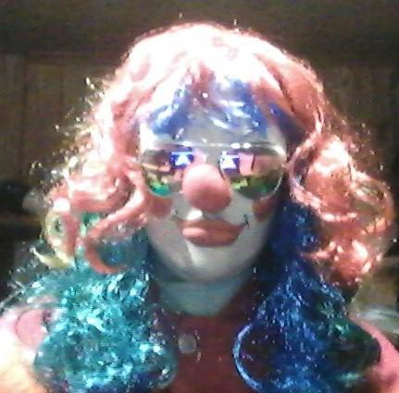

She has since studied at the Academy of Performing Arts in Clowning and in 2009 joined Clowns of America International, and as Reignbeau the Clown in 2010 wrote our third book Reignbeau’s Riddles and Rhymes.

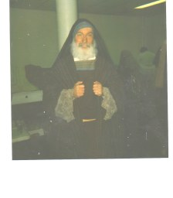 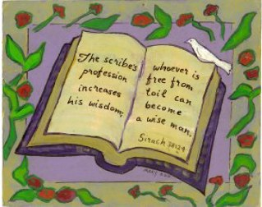 \
Mikhael Bar-Yosef was a scribe from the tribe of Levi. (see St. John Passion Play.)
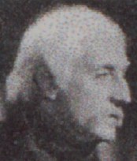
William Christian Sigerson, or as he was more affectionately called "Billy", was born Nov. 2, 1891 in Agra, India, the son of Norwegian explorer Wilhjalmar Sigurdsen and Italian circus performer Vittoria Ricoletti, and so destined for an exciting life. He was, as you may have noticed from the photo, a Basil Rathbone look-alike. He had worked as a pageboy in London, as a transvestite in the secret service during World War I, with Mr. E. in vaudeville, as a field agent for the M. P. Gibson and Lawston Foundations, as a tabloid journalist, as a barnstormer and was presumed dead in 1937 while attempting to fly over the Himalayas. He allegedly resurfaced in the Sixties as the Mahanimshi, authored several books including the counterculture classic, 'Gimme' Is My Mantra, founded the Mindak commune near the Minnesota-Dakota border, and frequently contributed to the Fortean Mysteries SIG and Holmesian Studies SIG newsletters, before again being presumed dead in 1996.
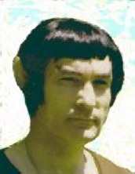
Spiek Dvllnoh is our resident Surakian and web master of the IDIC Institute, but otherwise a rather mysterious character, claiming to have been born in AV 8015 on alpha Zodiaci III.
Others that have helped with this web site include:
Mel Abelha, Al Anz, Jesus BarMariam, Humbert Beth, Tania Borealis, Lama Chhem Li, Lana Coperta, Ephrem Smith Corona, Margarita Coronae, Christi Crux, Beth Doa, Aben Ezra, Tom Flika, Gloria Frederici, Faith and Joy Fuller, Nero Gatto, Angelique Gilchrist, Marian Gillis, Tom Hoofd, Anthony Hoya, Rah Kakeshan, Pete Kidole, Bob Kabelka, Kitty Kindle, Tina Kuppi, Claire Lexmark, Gillian Ling, Tom Lomme, Ben Människa, Leo Marinus, Stella Maris, Hope Messenger, Mikha-El, Nga Mau,, Al Nahr, Nero Mercato, Rosa Mystica, Sara Mizu, Woz Niebeski, Norma Nilotica, Nero Occhio, Dan Oljuga, Isadore Hewlett Packard, Cal Pantof, Clair Peau, Jed Pero, Cal Rîde, Fred Rör, Tom Rymd, Kamika Schmidt, Stephanie Schutzengel, Beth Sefer, Dana Sevgi, Hilda Strasse, Dan Svjetlost, Anne Tabiat, Tavola Tafelberg, Tien Ho, Tina Tähti, Ben Torr, Zesta v'Rim, Karl Wagen, Charles Wayne, Lewis T. Williams and Sam Znowu.

and, of course, those who have contributed via Hierogamous House Guestbook (in chronological order):
Lori Crusham, J. Stuart, Jeff Orzechowski, Joel Senter, Liz Egan, Dr. Ed Rowland, Michael Yancey, Sean Williams, John vander Does, Vaughan Machado, Michael J. Duricy, Scott Noel, "Tadpole" Phelps, Dorothy "Irene" Ramsey, Phillip Minden, Frederic Rousseaux, Phyllis Rosley, Judy Monahan Eskine, Marianne Dixon Parmele, Crystal Welsh, Colin Ferguson, Deykin ap Gwion, Pete Coogan

