The Norbury Chronicle
newsletter of the Holmesian Studies SIG of American Mensa
since '88, Baker Street Irregulars scion since '95
"Nothing is concealed that will not be revealed." (Mark 4:22)
Issue IX April '91
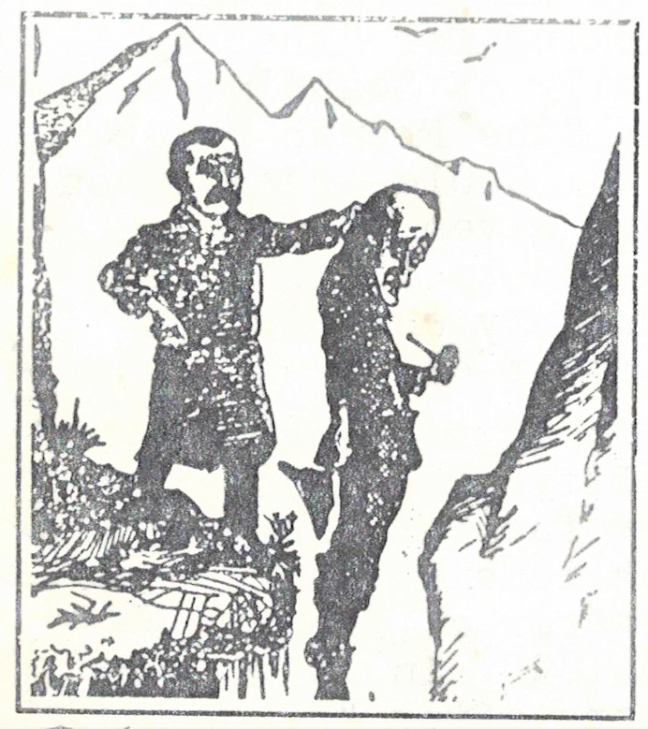

The Final Problem
The Cremona Fiddlers of Williamsburg, VA, are planning "The Final Problem" Workshop: Conan Doyle's Revenge for June 14-16 at the College of William and Mary. It is the second such Holmesian workshop offered by the group, the first being "Fiddling Around with Sherlock Holmes" in 1987. It will feature many scion scholars, including Dr. Al Rodin's "Conan Doyle vs. Sherlock Holmes: Birth, Death and Retribution", two quizzes by John Bennett Shaw on "The Man With the Twisted Lip" and "The Adventure of the Priory School", Holmes films, John Gardner with "The Truth about Moriarty's Underground" and Jean Upton's "A Challenge Well-met: Granada's Interpretation of the Canon." (Contact Ray Betzner, 2906 Richard Pace S., Williamsburg, VA 23185 to make reservations or as they put it: "Come to Williamsburg in June, 1991, if convenient -- If inconvenient, come all the same.")
What actually happened that April one hundred years ago, what was Holmes hiding and from whom between 1891 and 1903m cannot be completely resolved, but we do have some thoughts on the Final Problem. Holmes was quite a secretive individual as can be easily seen from his hiding his knowledge of literature, philosophy, gardening when first acquainted with Watson, his protection of his brother Mycroft's anonymity -- and his sisters'. (Only referred to in his remark during the Rucastle case, his "muttering" Watson calls it "that no sister of his should ever have accepted" a situation at the Ricastles'.)
Watson only mentions Holmes' refuges in which he changes personalities until the publication of "Black Peter" in 1904, long after he left London. Watson kept secrets too.
"What you do in this world is a matter of no consequence. The question is, what can you make people believe that you have done?" he is quoted as saying in the conclusion of "A Study in Scarlet".
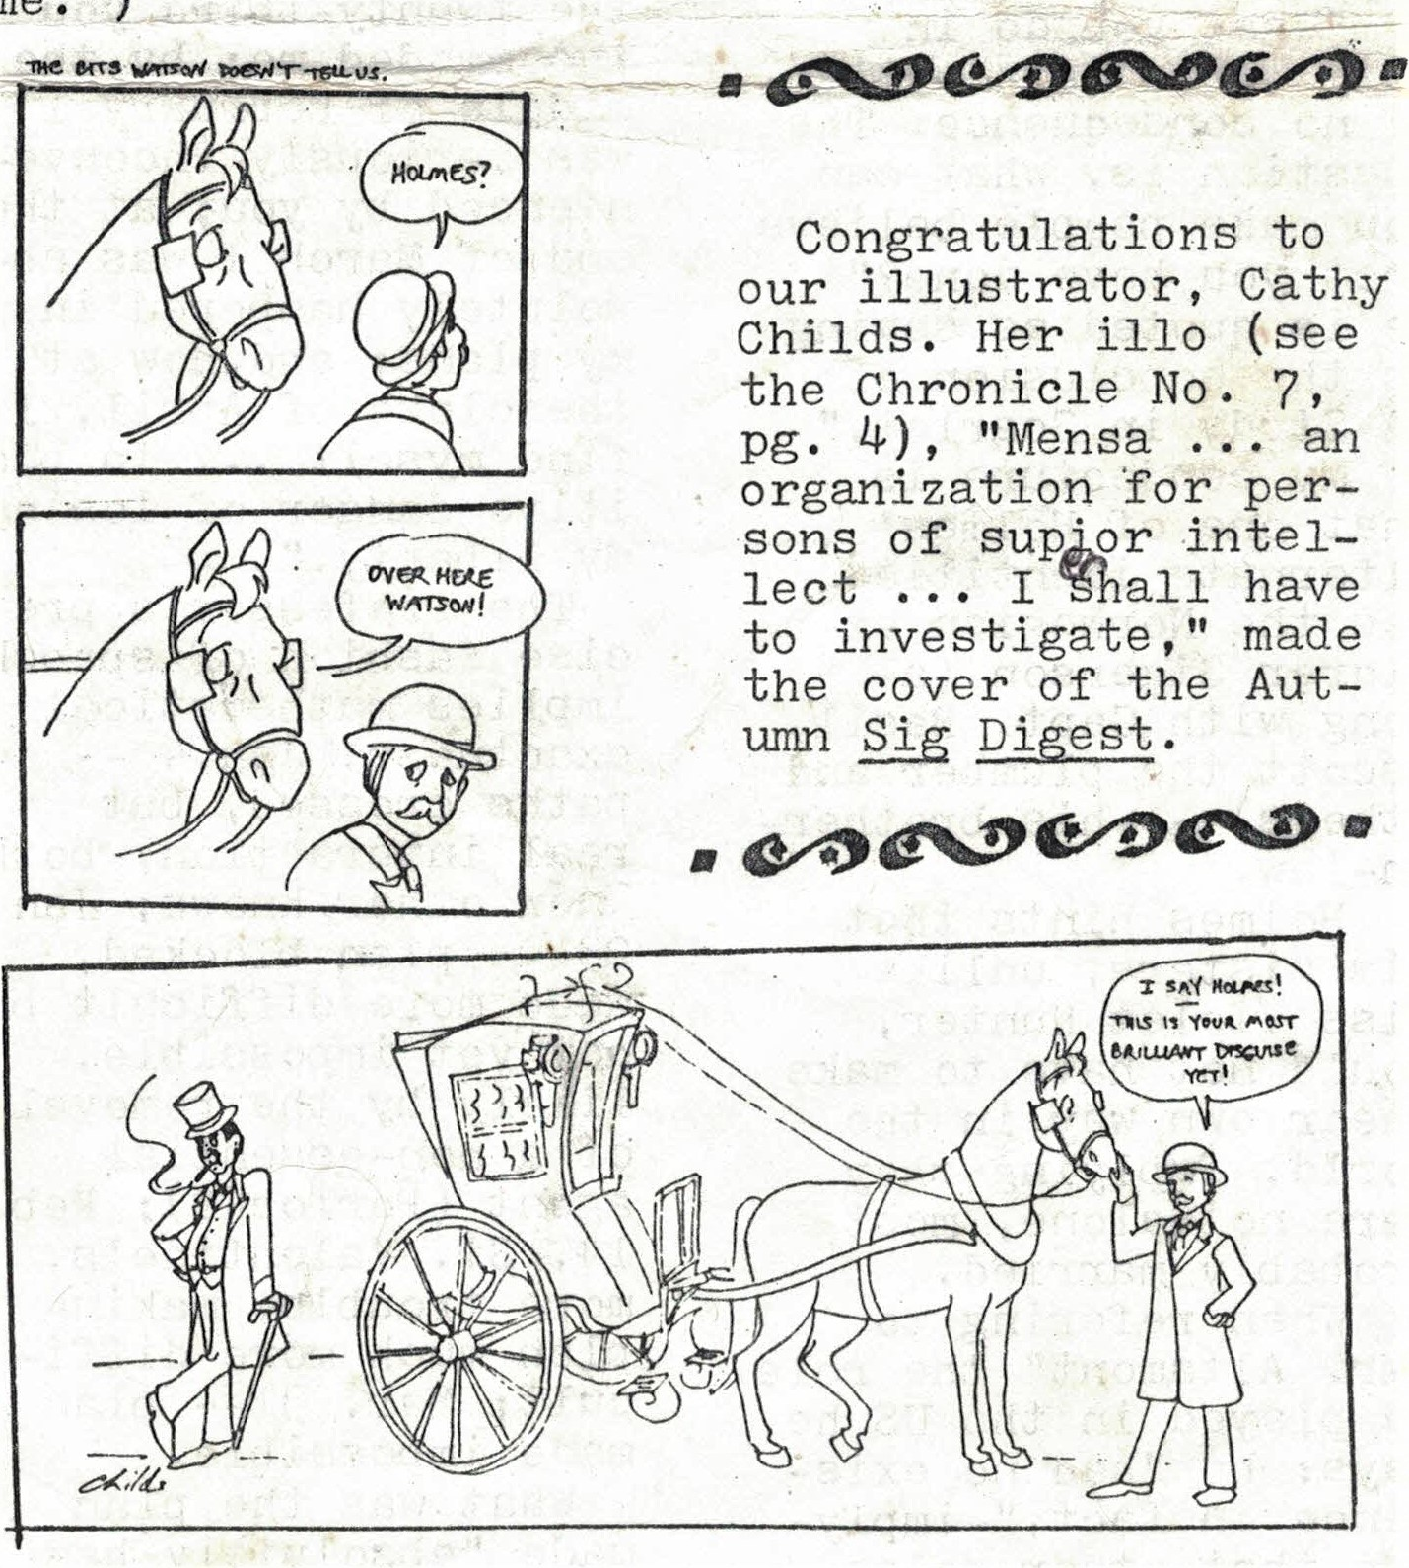

My conjecture is that one of Holmes' alternate identities was the Norwegian explorer Sigerson (along with Capt. Basil, Escott the plumber and others) -- his brother-in-law. Holmes hints that his sisters, unlike Miss Violet Hunter, would not have to make their own way in the world, implying they were not alone, most probably married.
When referring to "Mr. Altamont", the role he played in the U. S., he says: he "had no existence in fact", implying that other roles did, that Holmes at least sometimes impersonated people who did, in fact, exist. They would necessarily have to be people whom he knew intimately both to impersonate and to know certainly would not "blow his cover". he certainly wouldn't make the same mistakes as Windibank, Clay, Peters, Edwards or Murillo. He would have learned from his deceptions by Jefferson Hope's friend and Irene Norton.
The key to what happened lays behind Moriarty's reported statement: "You crossed my path on the fourth of January. On the twenty-third you incommoded me; by the middle of February I was seriously inconvenienced by you; at the end of March I was absolutely hampered in my plans; and now at the close of April, I find myself ... in positive danger of losing my liberty."
The professor's precise fashion of speech implies mathematical exactness: Jan 4 -- paths crossed, but no real interaction, both know other's plans; Jan. 23 -- plan blocked, made more difficult, but not yet impossible, likely by the removal of a non-essential agent (Porlock?); Feb. 14, St. Valentine's, more trouble, making plan much more difficult; Mar. 31 -- plan made impossible. What was the plan made "absolutely hampered" March 31? Could it have been a marriage like Lord St. Simon's made impossible by the appearance of the bride's husband? Or the disappearance of the groom as in Miss Sutherland's? Or both?
Watson clues us in that Holmes was during this winter of '90-'91 working for "the royal family of Scandinavia" and "the French republic". Could these cases have given him clues needed to finally trap Moriarty and his network of crime?
An intriguing possibility is suggested by the fact that Heinrich Schliemann, famed discoverer of Troy, died in 1890. In 1912, Paul Schliemann revealed his grandfather's deathbed secret, the clues to a quest Paul began when he had studied and inherited enough -- clues in Lhasa (a 2nd Century Chaldean tablet), east of the temple of Sais, Egypt, in Phoenicia, Tiahuanaco, Bolivia; clues to Atlantis.
Le Pongeon's manuscript of the last surviving Mayan texts was lost in 1881 -- or so it is thought. Could that be what the French government was interested in? What took a certain "Norwegian explorer" to Tibet and North Africa?
Paul Shliemann promised a book, supposedly finished before August 1914, after Holmes' American expedition, but as he said, "We have our diplomatic secrets." It's "the most brilliant bit of thust-and-parry work in the history of detection", but untold. Why not Atlantis?
Letters
In reply to John Zeglin's letter concerning the possible relationship between Nero Wolf and Sherlock Holmes, I note that the only known photograph of Holmes, on display in a little alcove adjacent to 221 B, Baker St., London, was taken in Cetinje, the old capital of the kingdom of Montenegro (Crna Gora, now part of Yugoslavia). This placement of Holmes in Montenegro at a crucial time may have contributed to the father theory.
As an avid reader of Archie Goodwin's chronicles, I wonder if anyone else has noticed the significance of the names in the narratives. Archie offers no comment, but readily admits he and Serbo-Croatian are not on speaking terms. At any rate, the theory that Marko Vukcic was Wolf's brother is supported by the fact that the family name, Vukcic, means "little wolf". Although Archie would quickly point out Wolfe is anything but little, it is plausible that the name had been Anglicized to Wolfe.\Wolfe's long-time nemesis, his Moriartym was Arnold Zeck. The initials "A. Z." certainly hint at the comprehensive nature of his crimes, but we may also note that "Zeck" is the English pronunciation of the Serbo-Croatian "zec" meaning "hare" or "rabbit", Zeck, it would seem, was easy pray for Vuk, the wolf!
I invite comment from other vukofili (Wolfe fans).
Cathy Childs

Dear Mike,
While you're discussing the paternity of Nero Wolfe, I'd like to get straight the rumor that yours truly is also so sired. My birth at the old fort in Agra is well documented by none other than Rev. Joshua Stone. The theory that Holmes under the assumed name of "Sigerson" was my father arose as soon as The Strand published the fact in November 1903 -- when I was 12. My classmates seemed to think there was some resemblance.
Rev. Stone never doubted my mother's story, but later I learned the whole truth. Maybe I'll tell you some time. It involves a certain delicate situation with the Scandinavian royal family's Bohemian in-laws.
William C. Sigerson
Porlock's Puzzles
A simple coded and decoded cipher is a variation of the pangrammic code. Rather than indicating the word and letter in the word as we did with the Box 503 cipher, this issue uses the months of the year. for example, to encode "It is with a heavy heart I take up my pen..." you would write say 44 for the "I", meaning the fourth letter in the fourth month, APRIL. For the "T" we'd have 86 and so on to get:
44864491141449435123522151131735642616103448632199225423128939963
Note that since there are no W's or K's in the months, W became UU and K took the null 19 -- there are only seven letters in January. The multiple designations for each letter ("E" has nine, for example.) and the use of nulls (Out of the numbers between 11 and 128, 36.7% are nulls, without a corresponding letter assignment.) The cipher can be quite indecipherable, more so at least than the word-substitution code by my namesake in The Valley of Fear. Now that you know the principles, try reading the classifieds.
Classifieds
1031013732778327985288103514410063121111112863544638366449191115814511973
-- Box 901
