The Norbury Chronicle
newsletter of the Holmesian Studies SIG of American Mensa
since '88, Baker Street Irregulars scion since '95
"Nothing is concealed that will not be revealed." (Mark 4:22)
Issue XV Spring '95
On Canonical Abbreviations
My dear Halm,
The Fall issue of the Norbury Chronicle has been in my in-tray for some time -- I have found it impossible to keep everything jackknife-pinned, and anyway I have no mantlepiece. There are a number of fascinating items in the NC. But first my name is not "Ronald Redmont". [Sorry Donald!]
The item in NC about Canonical abbreviations is interesting in comparison with the Franco-Midland Hardware Co. proposal. In addition to the J. F. Christ abbreviations for the sixty Canonical cases, they have added five-letter abbreviations for the standard compilations of the stories:
ADVEN The Adventures of Sherlock Holmes
CASEB The Casebook of Sherlock Holmes
COMPL The Complete Sherlock Holmes
HOUND The Hound of the Baskervilles
LASTB His Last Bow
LONGS John Murry edition of the long stories
MEMOI The Memoirs of Sherlock Holmes
OXFOR The Oxford 9-volume Sherlock Holmes
RETUR The Return of Sherlock Holmes
SHORT John Murry edition of the short stories
SIGN4 The Sign of the Four
STUDY A Study in Scarlet
VALLE The Valley of Fear
I cannot say that these are felicitous nor all necessary.
Also, my son Chris ("Billy" BSI) in 1965 published and has recently issued a new edition of The Tin Dispatch-Box, a compilation of the unpublished (or unreported) cases of Mr. Holmes, as well as the Exploits, which you mentioned in NC and assigned to each a five-letter short form. In the order you mentioned in the Fall NC they would be SEVEN, GOLDH, WAXGA, HIGHG, BLACB, SEALD, FOULK, ABBAS, DARKA, 2WOMN, DEPTF and REDWI.
Your idea of paragraph and sentence citations is interesting, the draw back being the necessity of numbering one's own copy of the Canon. [Or counting up to a hundred or more paragraphs, if you can't simply turn to the passage from memory.] The usual form is the page reference in a standard edition (most likely in the USA the Doubleday; in the UK it used to be the Murry, may now be the Oxford).
[Ed: When I first saw the usage in The Deal Table (newsletter of the Fragile Instruments of Sherlock Holmes, I took it as the usual and have used it ever since.]
I fail altogether to follow your argument (last col., pg. 2) regarding Holmes' relatives.
Sherlogically yours,
Donald A. Redmond

[Maybe we'll try to sort out the relativity theories again sometime, but to continue with the code: Noe that I think on it five and even four letters are not very short forms. The New American edition of the Bible (after which the Canon scholarship is being patterned) uses only two letter abbreviations (with an occasional number as for 1 and 2 Tm (Timothy)).
With a bit of creativity, the stories (not excluding the deuterocanonical Exploits) can all be assigned such two-letter abrevations. All but 21 can be abbreviated to the title's key words intials. Seven can be reduced to the first initial and the next letter and the rest to the first initial and a later consonant, for the purpose of eliminating ambiguous designations. Thus:
AG Abbe Grange, AR Abbas Ruby, BB Black Baron, BC Blue Carbuncle, Be Beryl Coronet, BP Black Peter, Br Bruce-Partington Plans, BS Blanched Soldier, BV Boscombe Valley Mystery, CA Charles Augustus Milverton, Ca Cardboard Box, Ck Crooked Man, Co Copper Beeches, Cp Creeping Man, DA Dark Angels, DD Dying Detective, DF Devil's Foot, DH Deptford Horror, DM Dancing Men, EH Empty House, ET Engineer's Thumb, FO Five Orange Pips, FP Final Problem, FR Foulks Rath, Gb Three Gables, GH Gold Hunter, GI Greek Interpreter, GP Golden Pince-nez, Gr Three Garridebs, GS Gloria Scott, HM Highgate Miracle, HO Hound of the Baskervilles, Id Case of Identity, LB Last Bow, LF Lady Francis Carfax, LM Lion's Mane, MR Musgrave Ritual, MS Mazarin Stone, MT Missing Three-quarters, MW Man with a Twisted Lip, Nb Noble Bachelor, Nr Norwood Builder, NT Naval Treaty, PS Priory School, Rd Red Circle, Rg Reigate Puzzle, RL Red-headed League, Rs Resident Patient, Rt Retired Colourman, RW Red Widow, SB Speckled Band, Sd Study in Scarlet, Sk Stokbroker's Clerk, SN Six Napoleons, Sn Scandal in Bohemia, SO Shoscombe Old Place, So Solitary Cyclist, SR Sealed Room, SS Second Stain, SR Sealed Room, SS Second Stain, SV Sussex Vampire, Sv Seven Clocks, TS Three Students, TW Two Women, VF Valley of Fear, VL Veiled Lodger, WG Wax Gamblers, WL Wisteria Lodge, YF Yellow Face]

B. S. I.
Since we have now been recognized as a scion of the Baker St. Irregulars (which includes Adventuresses), we ought to begin to choose our aliuses, or rather noms de plume from the story from which we take the name of our newsletter, YF.
You may choose from the following possibilities on a first-come-first-served basis. I take "Friend at Norbury" which leaves: (for Irregulars) "Gentleman Here Asking", "Idle Man", "Judicious Man", "Man Who Is Under the Influence", "Man Who Seldom Took Exercise", "Not A Very Good Man", (for Adventuresses) "Amber Mouthpiece", "Coarse, Rough Woman", "Faithful Scotch Woman", "Little Coal-black Negress", "Nervous, Highly Strung Woman", "Old Woman", "Old Woman", "Some Unscupulous Woman", "Tall, Gaunt Woman), (either Irregulars or Adventuresses) "Bootlace", "Creature Who Lives", "Dark Blur Moving", "Good Long Stem", "Hop Merchant", "Just A Field", "Lawyer", "Long, Thin Forefinger", "Nice Old Brier", "Scotch Fir", "Singl;e Cottage", "Watch" -- an interesting assortment of characters.
These might be amended since some are already shortened. If full we have "Man Who Is Under the Influence of Extreme Emotion", "Man Who Seldom Took Exercise for Exercise's Sake" and "Creature Who Lives in the Only Comfortable Room in the Place", which are quite different meanings. Or perhaps you'd prefer shortening another to "A Very Good Man"?
I'm already fond of "Friend At Norbury"; it abbreviates to FAN.
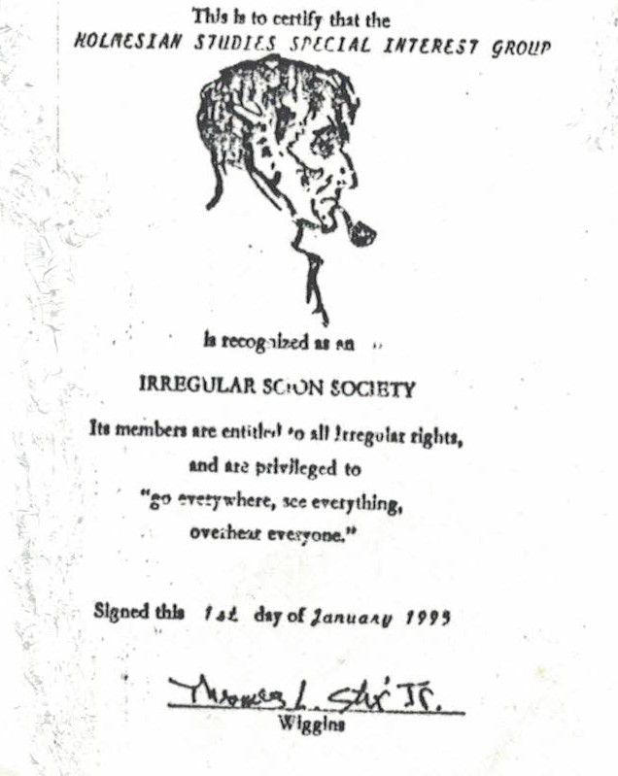

On the Telly
Noe that the local station here that had been airing the Fifties' British TV series "Sherlock Holmes" is now not, we thought we'd share some of the non-canonical dialogue from our records. They are interesting.
From "The Case of the Baker St. Nursemaids": After Watson and Holmes find the proverbial baby in a basket at their door, we have:
W: "What is it?"
H: "Well, it's obvious. Isn't it?"
W: "Holmes, you never told me!"
H: "Told you what?"
Watson points to the baby in the basket.
H: "I haven't got one -- or I haven't until now!"
W: "Where did it come from?"
H: "I don't know. I was there." (Holmes points to the bedroom.)
W: "What do we do now?"
H: "Well, you're the doctor."
W: "I,m not that kind of a doctor ..."
H: "Oh, I see."
Another memorable scene is in "The Case of the Neurotic Detective" when Watson, suspecting Holmes is the elusive Master Criminal of London, tries to trail the Master Detective in disguise as a cabby.
H: "What in Heaven's name are you doing her?"
W: "This, sir, is where the cabby usually sits."
H: "No, really, Watson?"
W: "I'm sorry, sir. I think you've made a mistake. My name isn't ... It's Sedgeley, sir."
H: "May I give you some advice, 'cabby'? The corners of your beard are badly in need of repair. Most extraordinary behavior! Ah, a legitimate carriage. Cabby! Cabby! Good day, 'Sedgeley'."
Another is the story of the MacGregan treasure. The poem of the family ghost give the vital clue: "Reflect and then ye will plainly see the MacGregan fortune hung in me. A curse on all who dare conspire to take me doon from o'er the fire."
After the "Haunted Gainsborough" disappears from its frame, Heather reappears and says: "It is my own portrait and you will not sell it, Malcolm MacGregan." Archibald Ross, the foreclosing mortgage-holder warns who he thinks is his actress accomplice not to deviate from the lines, but is it her?
As they are leaving the castle, Holmes and Watson see her again and we hear:
Heather: "Thank you for what you've done, Mr. Holmes."
Holmes: "You're very welcome, Heather."
[Notice how Holmes calls her by the ghostly ancestress's name?]
Heather: "Thank you for finding the treasure and saving the castle."
Holmes: "Your too good an actress for this kind of work, Heather."
[Notice how Holmes once again uses the ghost's name? What work is he refering to? Stealing the portrait? Haunting?]
Watson obliviously puts in: "But I was up to your tricks all along though."
Heather, smiling: "It would be very difficult for a woman to fool a strong and intelligent like you, Dr, Watson. Good day and good trip."
After Holmes and Watson leave Heather returns to her place in the fireplace under the portrait.
Although Holmes once said, "No ghosts need apply." (SV 9:5) c. '88, by '90 he's on the trail of "king devil". (BS 1:5-6, VF 2:7, 90:3)
100 Years Ago
In 1895 Holmes was said to be in his best form since 1883 (BP 1:1) and so could afford to turn down illustrious clients. (1:2) He investigated the John Vincent Hardin persecution (So 2:2) and the Violet Smith kidnapping (So) in April. In June he dealt with Wilson. (BP 2:1, DH) He's so good Pope Leo XII calls him in on a case (BP 2:1) and fifty men want him dead -- and how many women? (Br 9)
Did he investigate the Oxford UFO August 31? The Fennville train robbery? The Stefan Stambulov assassination? The annual July 12 quake in Comrie, Scotland? What took "Sigerson" and Watson to Norway? (BP 196:4)

