The Norbury Chronicle
newsletter of the Holmesian Studies SIG of American Mensa
since '88, Baker Street Irregulars scion since '95
"Nothing is concealed that will not be revealed." (Mark 4:22)
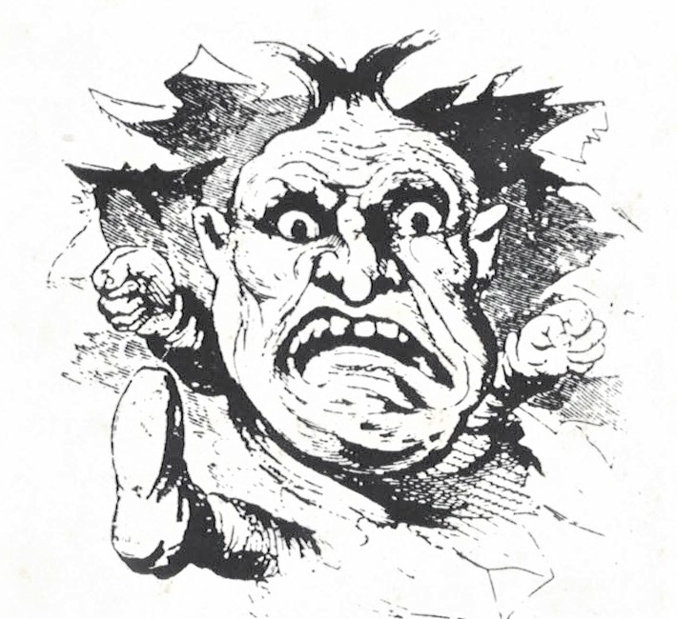
Issue VIII October '90

'Orrible Murder
Leonard de Vries in his 'Orrible Murder shares stories and illustrations from vintage Victorian Illustrated Police News. The original yellow journalism featured such cases as "Frightful Wife Murder in Bristol", "fearful Scene --Woman Torn to Pieces", "Murder and Mutilation of a Woman", the same sexploitation we have yet with us in our own century.
Other entertaining pieces illustrated "Capital Punishments of All Nations", "Singular Method of Execution: and -- moving from the gross to the fantastic -- "Death from Swallowing a Mouse" or "Frightful Encounter with a Sea Devil".
Most popular however was likely "The Whitechapel Tragedy". (See "Ripper Case Closed" Norbury Chronicle No. 3)
Northern Musgraves
by Katherine White, Co-president
The initial idea of bringing together a group of Sherlockians from the north of England took root in the November of the centenary year, 1987. [The same as the Homesian Studies SIG.] Since then the new society, the Northern Musgraves, has firmly established itself with a growing core of attending enthusiasts and a total current membership of over a hundred and twenty. This includes many overseas members and we also have the kind support of our Honorary Members, Peter Cushing, Michael Cox, Jeremy Brett and Edward Hardwick.
The society's primary achievement lies in having met an obvious need; in filling a geographical gap, we now provide a contact point, activities, publications and meetings for members living too far afield to attend all of London Society's gatherings. The Northern Musgraves aim to complement the parent society and we have also established our own identity. Elements of our success include a lively approach to the Baker Street world and an attempt to provide a friendly balance of activities to suit most people. We also aim to guide young people and newcomers in their appreciation of the Canon.
[The list of activities includes: discussions of Holmesian studies, a visit to Doyles' alma mater, Stoneyhurst, drama, guest speakers, the Tonga cruise of the River Ouse, York, with a re-enactment of the spilling of the Agra treasure, quizzes, games, reviews, ...]
At all our gatherings we drink the Musgrave toast: "For the sake of the trust" and we musttry to illuminate a sometimes grey world by bearing in mind Holmes' observation in 3GAR that "there are always some lunatics about. It would be a dull world without them."
Letters
Dear Michael,
Your name was mentioned in the first newsletter of the British Mensa Sherlock Holmes SIG. I understand that you run an association called the Norbury Chronicle and I would be very pleased to find out if overseas members can take part.
I am a member of the Sherlock Holmes Society of London and am the Membership Secretary of a two-year-old group known as the Northern Musgraves. We currently have 130 members including several from the USA. I enclose some information on our society and a copy of our latest newsletter, which I hope you find of interest.
Our main publication is an annual journal, The Musgrave Papers. This year's is just out [i. e., as of Aug. 1] and is a special edition featuring Watson. At 90 pages it is quite substantial!
John Addy

Dear Michael,
The suggestion that Nero Wolfe is the son of Sherlock Holmes was first published by Bernard De Voto in the July, 1954, issue of Harper's Magazine and elaborated by John D. Clark in the January, 1956, issue of The Baker Street Journal and then given wide publicity by William S. Baring-Gould in his biographiesmof Sherlock Holmes and Nero Wolfe. It's certainly an intriguing proposal, despite the chronological problems (the chronology of Nero Wolfe saga is a complicated as that of the Canon) and there has been considerable pro-and-con discussion over the years by members of the Wolfe Pack.
The Wolfe Pack, Box 822, Ansonia Station, New York, NY 10023

Dear Mike,
Belated thanks for sending the sample of the Norbury Chronicle. The arrival of the next issue has made a believer of me -- enclosed is my $3 to confirm my subscription.
Cathy Childs is making a commendable effort to illustrate the Master, although I think the one used on page 1 of the May issue suggests that she is a trifle disrespectful. Shame on her. The page 4 drawing is far more acceptable.
[The caption on page on page 1: "It's not easy being a genius!" is certainly true and appreciated by Mensans, Holmes seems to be a bit smug about it -- or is it irony? Perhaps it's a reference to Yardish "geniuses".]
Inasmuch as Childs admits she has only a TV series to work from, it might be of interest to her if she can examine The Private Life of Sherlock Holmes by Vincent Starrett (University of Chicago, 1960, Pinnacle Books, New York, 1975). My paperback copy (the Pinnacle edition) has a number of illustrations by various artists, including a very poor one by Charles Doyle (Sir Arthur's father) used in the first reprint of A Study in Scarlet. Of course, the editions of the Adventures now being sold in stores contain illustrations from the Strand Magazine.
Which brings me to Isaac Asimov. (All good Mensans know him!) In his How to Enjoy Writing he has a chapter of Words vs. Pictures, in which he defends the right of individual taste when we create our visions of literary characters. But then he says, "Sherlock Holmes in my mind just happens to be Basil Rathbone." How utterly correct!
[My housemate, who also has not read the Canon agrees.]
One last word: I am pleased to see that The Seven Percent Solution by Nicholas Meyer was recognized as one of the worst patiches. Holmes may have has a minor weakness at an early time in his life, but Meyer's attempt to make a dope addict of him is the vilest canard.
Roy Charles Steeley
[We agree. Did Watson not describe the "performance" and note it was done with "extreme deliberation"? (SIGN 2, 3) In paragraph 11 Holmes pleaded: "Give me problems, give me work, give me the most abstruse cryptogram, or the most intricate analysis, and ... I can dispense then with artificial stimulants." Is it not reasonable that obliging Watson obliged?]
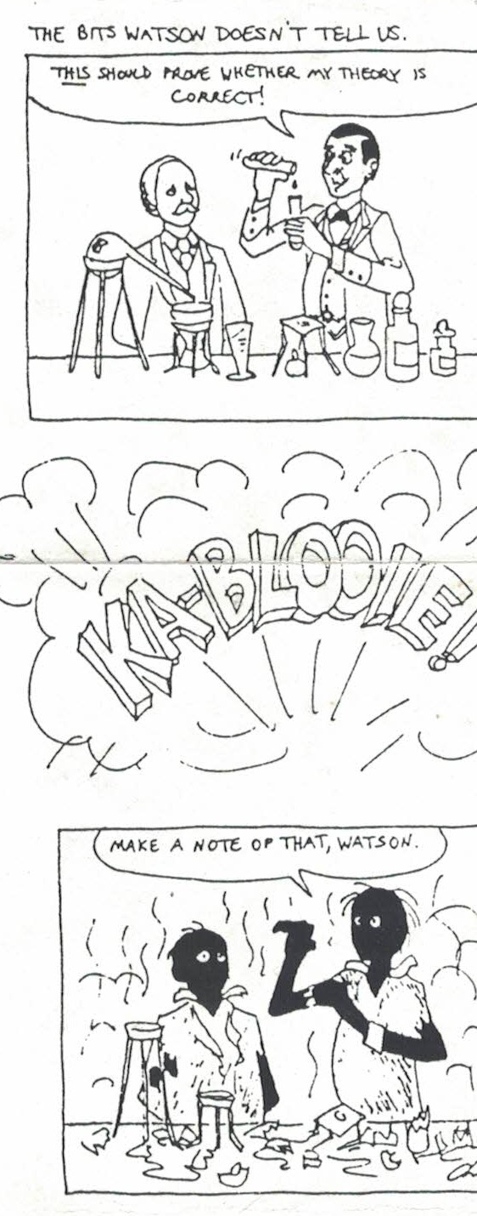

Dear Michael,
I'm interested in the Holmesian Studies SIG. I'm already a member of the Sound of the Baskervilles (the local scion of the Baker Street Irregulars).
T. Joseph McNabb, Jr.

Dear Michael,
I agree with Ratzannegger's pattern for Holmes tales (and patiches). I have written several patiches myself (involving the adventures of Vericlavius and his associate Doctor Quiddius in a vaguely Greco-Roman fantasy world) and I found myself following very much the pattern he sets forth, though without analyzing it so thoroughly.
Regarding the Holmes room reconstructions (and the walking tour of London), I recall spending a warm and futile afternoon wandering around Baker Street in 1976 looking for the reconstruction (which at that time was on another street). I asked a policeman, who with Gregsonian ponderosity explained to me that Holmes wasn't real, ergo his apartment didn't exist. Eventually I did locate it, a small, dusty room off a pub; I recall it included Isadore Persano's worm unknown to science, though it did not drive me mad. This exhibit has since, I believe, been replaced by the one in the Sherlock Holmes Hotel, which I hope to visit someday.
I agree with you that the data regarding Nero Wolfe are too unreliable to permit any certainty regarding his parentage. Goodwin or Stout's decision that Godwin would always be in his 30's and Wolfe in his 50's makes havoc of chronology (though it has its advantages since otherwise Wolfe would have been close to 80 by the end of the series.) I might note that the notion Godwin was Wolfe's nephew is a fannish speculation of no more authority that Stout's infamous suggestion that Watson was a woman.
I tremendously enjoy the Wolfe tales (I may have re-read them, or some of them, more often than Holmes', which is saying a great deal.), but I don't believe in links between them and the Canon.
Several of the mystery shops you list are in areas I visit and I hope to reach them in due course. I value this sort of practical information highly.
John Leland
100 Years Ago
Oct. 9, 1890 The Red-Headed League dissolved
Nov. Culverton Smith attempts to murder Holmes
75 Years Ago
1915 "Der Hund von Baskervilles" and "Ein Schrei in der Nacht" made
Classifieds
PUBLICATIONS
Mysteries by Mail© P. O. Box 679, Boonville, CA 95415-0679

Elementary, My dear Reader in Japanese is a "must" for every serious Sherlockian bibliophile! Dificulties in currency exchange lead Mr. Tanaka to request $25 US in cash
Kiyoshi Tanaka, BSI, 8-7 Babacho, Isogo-ku, Yokohama City, Kanagawa, Japan 235

SERVICES
Sherlocktron is a Computerized, Remote Bulletin Board on Sherlock Holmes, Lists Societies, publications and purveyors are available (714)661-2192

The Victorian Guesthouse Bed & Breakfast, 601 N. Broadway St., Union City, MI 49094

15-disk set -- complete ASCII text of all 60 Sherlock Holmes stories,
text indexing/retreival software, text anaysis programs
PsyLogic Systems, Box 315, Tolland, CT 06084

ANYTHING RELATED TO SHERLOCK HOLMES & SIR ARTHUR CONAN DOYLE
BOUGHT --- SOLD --- TRADED
Robert C. Hess, 559 Potter Blvd., Brightwaters, NY 11718

PERSONAL
JCXG VJG PWODGT QH VJG HKTG FGRCTVOGPV DA AQWT RJQPG CPF WUG KV KP ECUG QH C HKTG! -- Sherlock the Safety Hound

