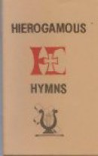
Hierogamous Hymns was the first publication of Hierogamous House publishing, published in January 2000, the Jubilee year. It is a collection of 80 song lyrics, many based on Scripture and written in adoration of the Blessed Sacrament, and written to familiar tunes. It is a sample of the songs in the expanded Psalms, Hymns and Inspired Songs: from Self-hate to Love through Scriptures. Although out of print they can still be requested from halm at hierogamous.com.

