The Norbury Chronicle
newsletter of the Holmesian Studies SIG of American Mensa
since '88, Baker Street Irregulars scion since '95
"Nothing is concealed that will not be revealed." (Mark 4:22)
Issue XII January '93
SIG News
Please note the change of address for the Holmesian Studies SIG and the editor of the Norbury Chronicle.
Collectibles
From The Sherlock Holmes Memorabilia Company we have "The unique case of the SHMC formation." It was started by the owners of an Estate Agency in Baker Street opposite Holmes' former home and offices who found themselves "drawn further and further into the magic" [as have we all.] If you care to see the range and the quality of their offerings simply write this address stating "How I Got Drawn Into the Magic" for a chance at the extra catalogue they sent us.
It includes deerstalker caps, meerschaum pipes, mugs, t-shirts, statuettes, busts, posters, postcards, board, card and video games. In their Collector Corner they even have such rarities as 1893 Strand Magazines, an exact facsimile of Beaton's Christmas Album's "A Study in Scarlet" or a first edition, autographed copy of Michael Pointer's The Public Life of Sherlock Holmes.
Through a sister company they can provide apartments to rent in all sizes in the Baker Street area from one week to however long your visit might be.
We have received a copy of Antiques & Auction News, May 22, 1992, which featured Sherlock Holmes collectibles in an article on collector Candie Lemaire. While an airline employee visiting London, she noticed Harrod's Department Store had neglected Holmes and Watson in their historical dolls collection. When she pointed this out to them they gave her a chance to purchase the first pair made by the House of Nisbet.
She also has Tobies from the Grand Cayman Islands, signed American Signature plates by Mitchell Hooks, along with the more easily obtained deerstalkers and meerschaums, mugs, shirts and, of course, books.
Letters
Hi --
I'm a member of the Bootmakers of Toronto, the Mycroft Holmes Society of Syracuse and the Society of the Baskervilles in Seattle. (The latter, of course, is known as the SOB.)
I have two papers that have been delivered, but not published. The Holmesian Studies SIG's Norbury Chronicle might be the place.
David Chimene
[It might indeed. We welcome any submissions. If they are too lengthy for one issue we would consider serializing. After all, it worked for the HOB, The Hound of the Baskervilles.]
Dear Mike,
Having recently joined Mensa, I was pleased to see your newsletter advertised in one of the inserts one receives as a new member. Having had the "bug" for years (for Holmes, that is) I would like very much to see a sample of your newsletter.
Thank you in advance,
Kevin Toomey

Michael --
Read about your Holmesian Studies SIG in the latest Bulletin. I enjoy reading about Sherlock's cases and am applying for four issues of your newsletter. I'm looking forward to some interesting reading.
Harold Platzek

Dear Colleagues,
I hope you are well and that your Holmesian efforts continue to flourish. May I add, "compliments of the season."
Our Tin Traders Corresponding Club is flourishing already with many letters received from all parts of the globe. For those of us who like to correspond we can actively deal with the matter of S. H. as much as we please. Meetings of our own societies are indispensable to our purpose, but what a pity they are so infrequent.
Just now our club is dealing with a timely and intriguing question and we would like to propose an hypothesis concerning the unrecorded activities of Mr. Holmes and we invite you to consider the facts.
The main points of interest are contained in "The Adventure of the Devil's Foot". Holmes had just received a consignment of books upon philology and was settling down to develop his thesis on connections between ancient Cornish and Chaldean when to his unfeigned delight he was called to Cornwall. This was a typical reaction of the man of action regardless of the brilliance of a mind in a theoretical pursuit.
But why was Holmes engaging his fertile mind with ancient Cornish and Chaldea? The answer is elementary and the facts, when understood, are obvious. Solving ciphers and decoding ancient languages are but two sides of the same coin. National security was never far from Holmes' thoughts, nor could it be since the foreign news of the day was filled with constant alarms. [That would be "in the spring of the year 1897."]
The work of the codebreakers was different from that of Champollion and Rawlinson [Jean François Champollion, decipherer of Egyptian, 1821, and Sir Henry Rawlinson, Assyriologist] only in the results of their work and Holmes' was attracted to proving the common origins of some parts of ancient Cornish and Chaldean in the same way other were drawn into the toils of Etruscan, Minoan Linear B and Mayan.
The books Holmes received before embarking with Watson upon "The Adventure of the Devil's Foot" included the standard reference works of the day. However, there were other volumes as well, one of which was more than likely Atlantis: The Antediluvian World by Ignatius Donelly (New York: Harper, 1882).
Now the business of codes and ciphers has two parallel objectives. On is to encipher, while the other is to decipher. These two demanding tasks were much on the minds of British Intelligence [i. e., Mycroft, Holmes' brother, etal.] as the world entered the dangerous and unpredictable Twentieth Century. The uncracked code, the Holy Grail of secret intelligence, is an objective pursued to this every day.
Consider ancient Egyptian hieroglyphics. Once the key was lost early in the first millennium the book was closed. Even when a plain text key became available with the discovery of the Rosetta Stone [in 1799] deciphering the Egyptian still took more than twenty years.
Champollion discovered that hieroglyphics could be pictographic, phonetic, ideographic, alphabetical or determinative and even could involve a kind of shorthand. Holmes was well acquainted with the thorough and painstaking analysis of the Rosetta Stone. His monograph of secret writings would, to be thorough, have asked, "How could one get PTOLMIS (Ptolemy) from
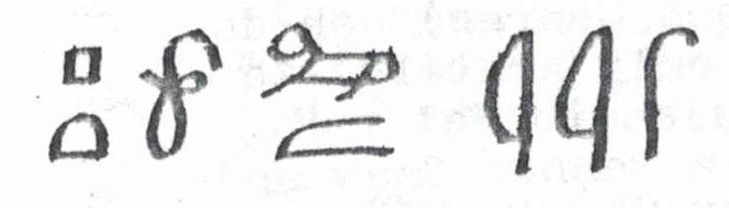

or KAISERIS (Caesar) from
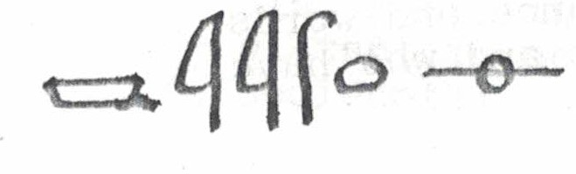

Holmes, it may be perceived, was working on a form of encipherment radically new, involving phonetics, "shorthand" and based on ancient languages, namely Phoenician and Cornish. Mycroft welcomed such research by his talented and energetic brother, especially at a time when British Intelligence was undergoingthe years of reform that would culminate in the establishment of M. I. 5 and M. I. 6 [M. I.1?] The new systemwas called New Phoenician or Newphone.
What would New Phoenician look like? Why "New Phoenician" at all? The Tin Traders, of course, those unwitting couriers of ancient tongues, the Cornishmen, would make their own.
The ancient Phoenician alphabet had 21 letters, but while based on the old alphabet New Phoenician included all 36 sounds in English. Holmes used borrowings from Greek, Anglo-Saxon and Gothic as well as modern phonics. [Anything but Chaldean, it would seem.] The effect would be to have a strange, ancient-looking alphabet, not readily amenable to interpretation, [by the uninformed], especially if the original Phoenician alphabetical order were preserved.
The advanced level of New Phoenician would be much abbreviated and vowel symbols would be virtually absent. Similarly spoken language rendered into Pitman's shorthand [Stenographic soundhand, 1837] gradually progressed in skill and speed. Vowel and diphthong marks were dropped and many contractions were used. Vowel values were indicated by the position of consonant symbols above, on or below the base line. Consonant values were indicated by the shape and thickness of the strokes.
In new Phoenician "Sherlock Holmes, the best and wisest man I have ever known" would be rendered in plain language:
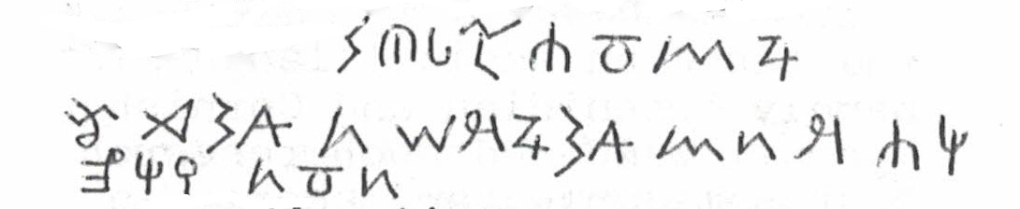

The "demotic" or advanced form would be thus:
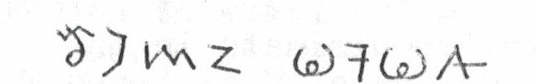

"The game's afoot."

Sherlock Holmes was a consulting detective and also a consultant to British Intelligence, [See "Greek Interpreter", "Second Stain", "Bruce-Parkington Plans", "The Naval Treaty" and "His Last Bow".] He usually had time to do both, but sometimes he disappeared [as in '91-'94 and '12-14] and, of course, many more stories are yet to be told.
We look forward to hearing from you soon. In any case you may expect to hear from us again. We have yet to tell you of enciphering in New Phoenician.
John D. Whitehouse
Hon. Sec. P. T. T.
and the students of 6-3 GT Pebble Hills School
El Paso, TX

I am now working at full speed on the biography [of S. H.], thanks in larg measure to Dr. George A. Vanderburgh of Shelburgh, Ont. While in New York for the Baker St. Irregulars and Adventuresses birthday festivities last January, George and I entered into an agreement that he would produce an electronic combined edition of my bibliography, which would be available on floppy discs to interested Sherlockians. By doing so, George would also be able to produce a camera-ready copy of the revised edition for the publisher.
Because the first two volumes are no longer in print, it is difficult, if not impossible to obtain them. For many Sherlockians and libraries that do not already have a copy, it would be pointless to provide cross references to numbers in earlier volumes. The new edition will also facilitate research in that users will have only one place to look instead of three.
In addition to adding new entries to the bibliography, I have started the mind-boggling task of reviewing and integrating some 20,000 cards for volumes 1-3. Many cards must be changed and re-typed before they can be sent to George. As soon as the cards are electronically scanned they are returned, along with a printout. Of course, I will also need to proofread the outprints so that further changes and corrections can be made. It's almost like doing the entire bibliography over. At least the entries for the Canon were already revised and integrated. In hindsight I wish I could start over again -- but with a computer! The revised edition should be available in 1994. It will be kept up to date with supplements.
I am not only grateful to George, but also to Peter E. Blau and John Bennet Shaw and all the other Sherlockians and Doyleans who have provided invaluable assistance and word of encouragement and who have sent complimentary copies of their journals and newsletters as well as newspaper articles about their activities and those of their scion societies. I have never given up on my bibliography just as my Sherlockian friends have never given up on me.
I also want to take this opportunity to thank Dr. LeMoyne W. Anderson, emeritus Director of Libraries at Colorado State University, for his support and for approving two sabbaticals and numerous other leaves so I could pursue my research activities.Like the Master Detectiv, I trust he too is enjoying a well-deserved retirement.
Thanks again to everyone for helping to make my dream become a reality,
Ronald B. De Waal
100 Years Ago
Dec. '92 "Silver Blaze" published
Jan. '93 "Cardboard Box", "Sigerson" in Tibet
Feb. "Yellow Face", HMS Caroline sees strange lights in sky between Shanghai and Japan
Mar. "Stockbroker's Clerk", strange light at Val-de-la-Haye, France
75 Years Ago
Dec. '17 Halifax munitions fire seen in dream, mysterious "blonde lady" seen in Sopwith triplane over France
Mar. '18 "Chung Ling Soo" (William E. Robinson) claims killing of assistant in act was accidental
Lot No. 249
We saw "Tales from the Darkside" ('90) on the "telly" recently and so compared their retelling of Sir Arthur's classic tale "Lot No. 249" with the original -- whose centennial is this years.
It followed the story quite closely (except for the almost unnoticable changes a hundred years makes to old Oxford).
The mystery of voices in Edward Bellingham's room, the attack on Long Norton, the murder of William Monkhouse Lee all remain virtually the same. But when it comes to destroying the mummy, Smith doesn't force Edward to do it, but does it himself with a chainsaw! (Like a bloodless chainsaw massacre.)
Smith then burns the mummy parts, the papyrus and Edward's thesis,or what he thinks is the papyrus with the secret of revivication. Edward is then able to revive the victims of thr revived mummy!
Ferrier Memorial
From the Avenging Angels, the Utah scion of the Baker Street Irregulars, we hear they had a memorial plague placed at or near Pioneer Trail State Park in memorium of John and Lucy Farrier, who died there in the summer of 1860, 132 years ago. They plan to make this year's first barbecue the first of many.
Contributors to the project will receive a certificate of appreciation (with $5 or more) and Jan "Sally Dennis" Walker's signed and numbered prints of Sherlock Holmes (with $25 or more).
Criminal
We have also received news of Sherlock Holmes' Victorian Criminal Classes or "Rogues, Rascals and Ruffians", sponsored by the Norwegian Explorers, University of Minnesota, next June. Besides the conference a visiting Holmesian could see Holmesian items at the U of M Wilson Library. They have William Gillette's scapbooks (the first actor to play Holmes), a wedding album and letters of Sir Arthur, manuscripts and notes of Gould's Annotated S. H., two pages from the manuscript of The Hound of the Baskervilles, copies of the 1887 Beeton's Christmas Annual and more.
The conference will be held at Holiday Inn Metrodome, June 11, 12 and 13. Write Norwegian Explorers Conference '93, 466 O. on Library, U of M, 309 19th Ave. S., Minneapolis, MN 55455
Holmes Review
In November the third Sherlock Holmes Review was held in Zionsville, IN. Speakers included Prof. Edward Lauterbach, BSI, Paul Herbert, William Cochran, Ely Leibow, Tom Stetak and Ruthan Stetak, covering Holmes himself, Sherlockiana, 221B Baker St., Dr. Joseph Bell and the Ohio and American connections of Holmes.

