The Norbury Chronicle
newsletter of the Holmesian Studies SIG of American Mensa
since '88, Baker Street Irregulars scion since '95
"Nothing is concealed that will not be revealed." (Mark 4:22)
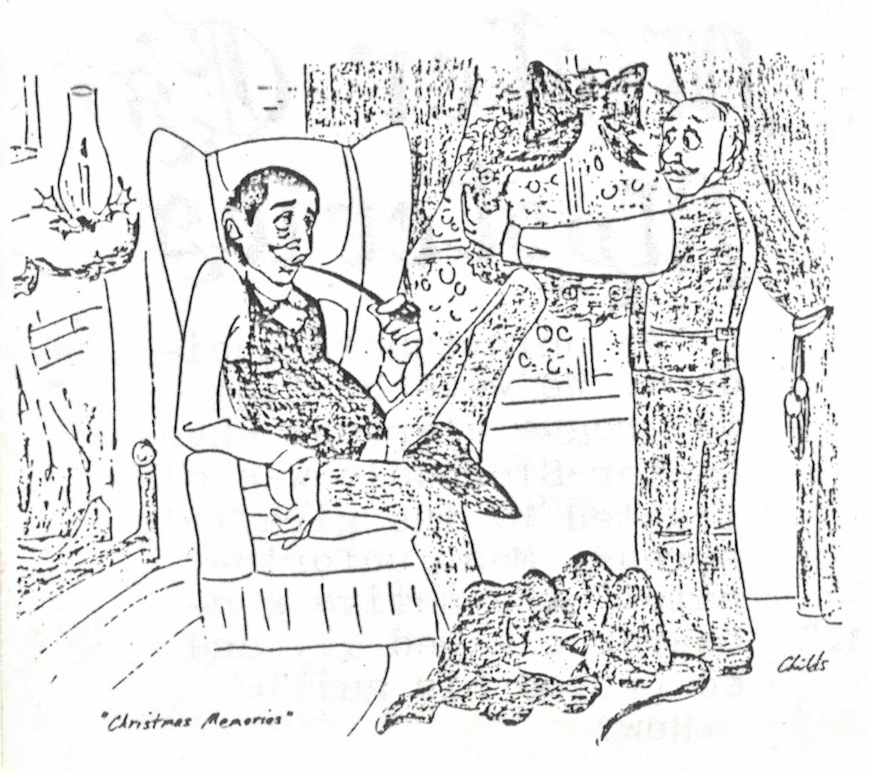
Issue X November '91
The Christmas picture here, presented by Cathy Childs, poses a mystery. Which window is Watson hanging the wreath on? In the introduction to "The Adventure of the Beryl Coronet" is mentioned "our bow window" overlooking Baker Street and in "The Problem of Thor Bridge" a bedroom or bathroom window in "our house" overlooking "the solitary plane tree". Is this Christmas memory perhaps remembering of old times back at Baker Street from Holmes' and Watson's "Valhalla" (Preface to The Casebook of Sherlock Holmes), Holmes' retirement retreat post-1903, or Mary and John's place to which Sherlock visited at Christmas time, say 1888?
Granada
In November the PBS "Mystery" series will again feature Jeremy Brett as Sherlock Holmes. In the Sherlock Holmes SIG Newsletter Number 2 George Long wrote: "The recent television series starring Jeremy Brett has attracted plenty of favorable comment from the devotees of the stories." and "Jeremy Brett, it seems to me, is alone in capturing the essential loneliness of the man, his inability to perceive the world through the eyes of ordinary people." We saw only an inability by the script writers to perceive through Watson's eyes.
The first Sherlock Holmes Gazette quotes Michael Cox, producer of the Granada films, as saying: "We will stick to the original Canon versions as near as possible."
In "Silver Blaze" Holmes' telegraph pole "trick" is deleted, his "that I may know my ground to-morrow" explanation becomes a weak "to stretch my legs" and his "You surpass yourself" to a mere "Thank you." It cuts Holmes' description to Brown "how the devil had shown him how he could hide the horse" and ends with Col. Ross entertaining Holmes in Devonshire rather than Holmes inviting the colonel near Clapham Junction. (Did our daring duo fly to this adventure? Where's our good ole Victorian carriage car?)
In "The Hound of the Baskervilles" they cut Holmes' reference to the devil again ("the devil's agents may be of flesh and blood") and the scene with cabby John Clayton (identified by some as the fifth duke of Greystoke) with Holmes' "completely taken aback" and bursting "into a hearty laugh". They make him a mail thief!
In "The Adventure of the Wisteria Lodge" they delete Holmes' praying as in "Pray sit down", all Holmes' dialogue with Inspector Gregson ("Wait a bit, Gregson." and his answer to Gregson's "You have a clue?") and have him, not John Warner, save Signora Durando. Even Holmes' revealing distinction between "strange" and "grotesque" and "horrible" cases is gone!
In "The Bruce-Partington Plans" they give the discovery of the newspapers to Watson -- of all people!
In "The Adventure pf the Devil's Foot" they have Holmes high on drugs when vicar Roundhay bursts in unexpectedly -- this in 1897, ten years after any reference by Watson. They have him say, "I thought I knew my Watson." and even "John!" They change Holmes' merciful understanding, even hopeful "Who knows?" to a "Wouldn't you?"
Personally we still prefer the Sherlock Holmes who fights the devil and his agents, is able to laugh, imagine himself loving or killing in revenge and face the horrible, while respecting his friend and clients and the law.
Of the shows we did not see ourselves we read that rabbit bones were substituted for Human in "The Norwood Builder", Moriarty enters into "The Red-headed League" and Watson nearly solves "Thor Bridge" and "The Musgrave Ritual"!
Not only did Holmes and Watson differ from the Canonical descriptions the stories do too. Selden does not die of a broken neck, Murillo murdered in Madrid or Col. Walter in prison. "All things are possible to the man who believes." We do not think Cox believes enough to make a faithful film version of the Canon ... but we can but try to hope so.
Recall?
On "Instant Recall" back in May they recalled Sherlock Holmes. They described him as "immortal", as "the detective's detective". They recalled his stories, which consistently sell better than anything except the Bible and his nearly 200 films.
The portrayal they noted especially was Basil Rathbone's. In fact they said: "Rathbone was Sherlock Holmes." Now that's an interesting conjecture -- was "Basil Rathbone" one of Holmes' "numerous disguises and names", his stage name? Did he play himself in films and on the radio in the late '30s and '40s -- at about 95?!
100 Years Ago
Oct. 1891 "the Boscombe Valley Mystery" appeared, yet Watson wrote "there is every prospect that the son and daughter may come to live happily together in ignorance of the black cloud which rests upon their past."
Nov. "The Five Orange Pips" appears and "The Adventure of the Beryl Coronet" is written
90 Years Ago
Fall 1901 The Hound of the Baskervilles serial and "Sherlock Holmes" play continue
Dec. Marconi sends first trans-Atlantic telegram
Mr. E.'s Mysteries
"An unfortunate accident! We were hunting the rogue elephant when Dr. Sterndale was distracted by the giraffe's scream. Most unfortunate!" the native gun-bearer claimed ... and so proved his guilt. How?
Letters
Nick Kimber asks:
Have you ever considered the problem of Victor Hatherley's thumb? In "The Engineer's Thumb" V. H escapes Lysander Stark by way of the window. He hangs from the window sill and Stark cuts off his thumb, thus causing him to fall. Yes?
Now if you hang from the window sill then surely the thumb must be against the vertical edge, so that a desperate criminal armed with an axe were to cut it off it would fall to the ground. So how come at the end of the story the thumb is found on the second floor window sill? Levitation? Any ideas?
[Engineer Hatherley, it seems, was hanging from the inner, not the outer, edge of the window sill, with his thumb and most of his hand upon the sill itself. In that case he was indeed fortunate that his whole hand was not found on that sill or his dead body bled lifeless somewhere before he found help.]

From John Leland:
A small point, as you are another Ohio Holmesian (I at least grew up as one, though am now in WV). It is a sorrow to me that the BSI in Cleveland did not choose to call themselves "the Glimpses In A Window" since a glimpse in a window in Cleveland, Ohio, told Jefferson Hope the whereabouts of Enoch J. Drebber. This is the only reference to our state I know of in the Canon.

Detection in the Bible
by Rev. Dr. Henry Shlessinger
The exclusion from the Bible of the last two chapters of the Book of Daniel merely because of the loss of the Hebrew original means a great loss to all. The stories of "Susanna" and "Bel and the Dragon are certainly proto-detective stories well worth preserving. The stories are dated as at the time after Cyrus defeated King Astyages of Babylon, 550 B. C.
The first uses the not cliché plot device of catching conspirators in their lie. Two judges, supposedly above suspicion, accuse Susanna of adultery, a capital offense. Daniel however questions them until he uncovers conflicting details in their story, two different trees under which the act was allegedly committed.
The second uses the footprint clue and secret door (rather like "The Adventure of the Golden Pincenez").
Books
Among the many Holmes-related books we have heard about recently is Match Wits with Sherlock Holmes, an adaptation by Murray Shaw, is an illustrated book in which to the original stories (SCAN, REDH, BLUE, COPP, GLOR, BLAC, SIXN and CARD) an examination of Holmes' methods has been added, aimed at middle grade readers.
Classifieds
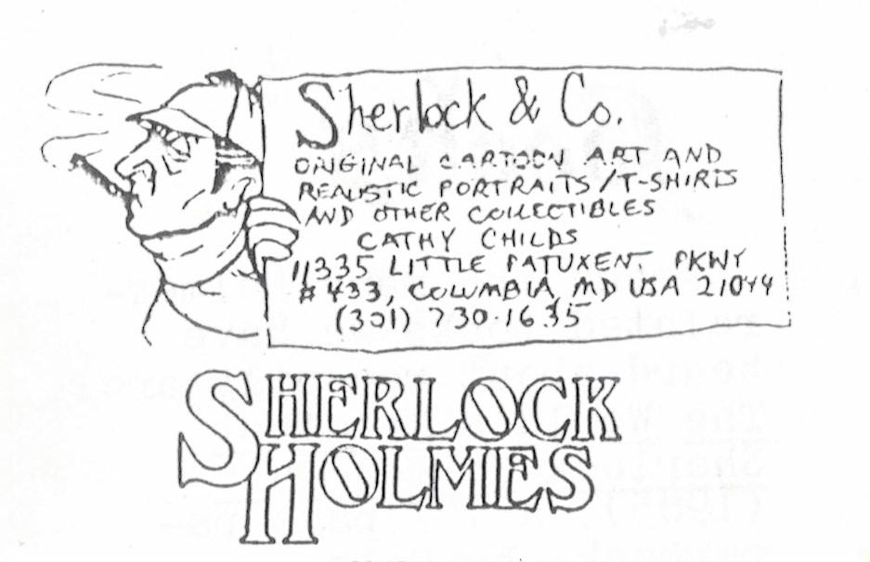

LIMITED NUMBER of pen-and-ink prints of an original portrait by Jan Walker are available from Gilded Lily, 1084 E. 250 S. Bountiful, UT 84010

SHERLOCKIAN PROFILE T-SHIRTS c/o Judith Culligan, 120 W. Pacific St., Appleton, Wisc. 54911 ($12 ppd)

SHERLOCK HOLMES AND DR. WATSON RUBBER STAMPS
Actual stamp size is 1"x1½" $5.50 for each stamp + $2 s&h, OH residence add sales tax
The Stamp Act 5805 Willow Glen Ct., Dayton, OH 45431

HOLMES BEVERAGE MUG white with black silhouette 1 for $17.95 + $2.50 s&h or
2 for $35 + $2.50 s&h Michigan residence add 4% sales tax
Send checks or money order to Holmes by Hall P. O. Box 221 B Dept. CS Flushing, MI 48433

221BBS A Sherlockian Bulletin Board System (415)949-1734
Brian & Charlotte Erickson, SysOp
Sherlockian Trading Post, Sherlockian Reference Libraries, Current Holmesian events
Assorted Disjecta Membra & Much More!

